Search for the required section

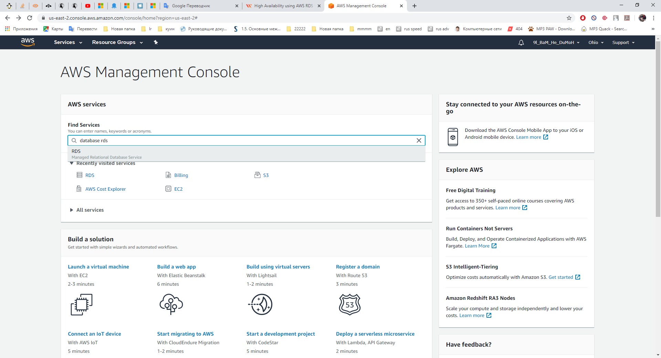

Select “Create database”

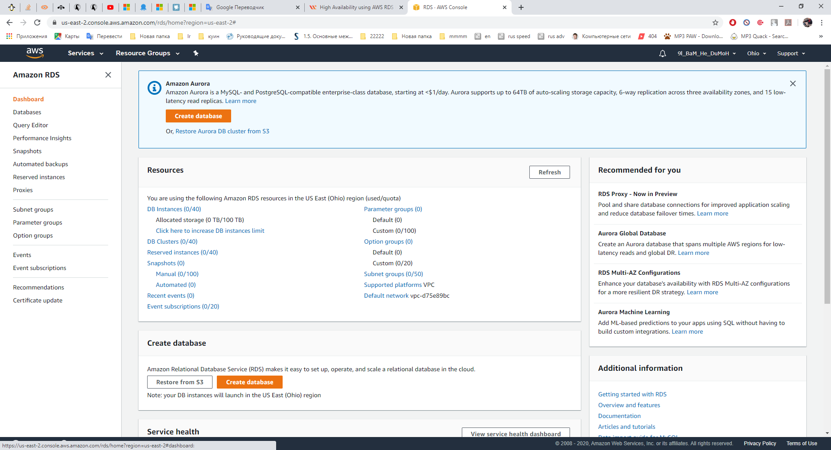

Choose the required options

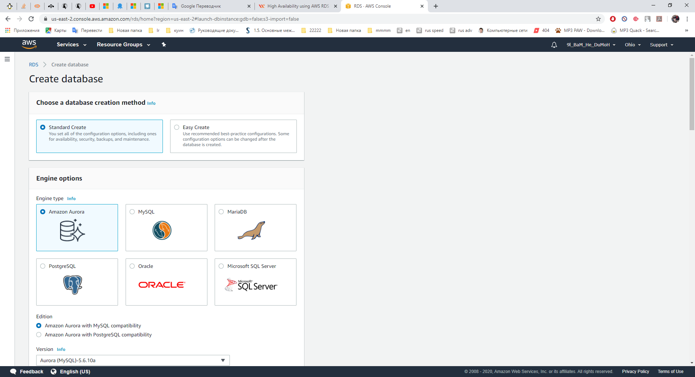

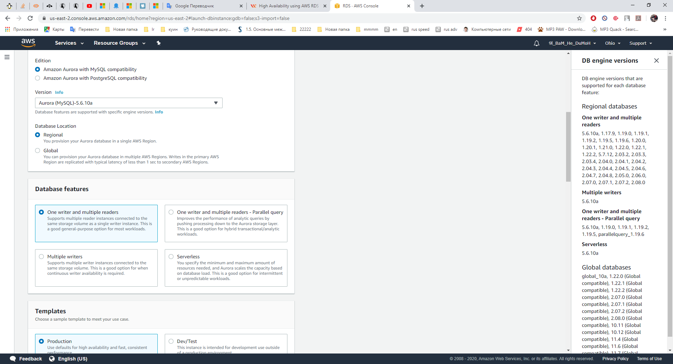

“Database features” is very important part of configuration. This part of the configuration defines the function of this database. For example: one writer and multiple readers - Parallel query – this type of database is very similar to the database of mobile or internet provider.

Set up cluster identifier and security

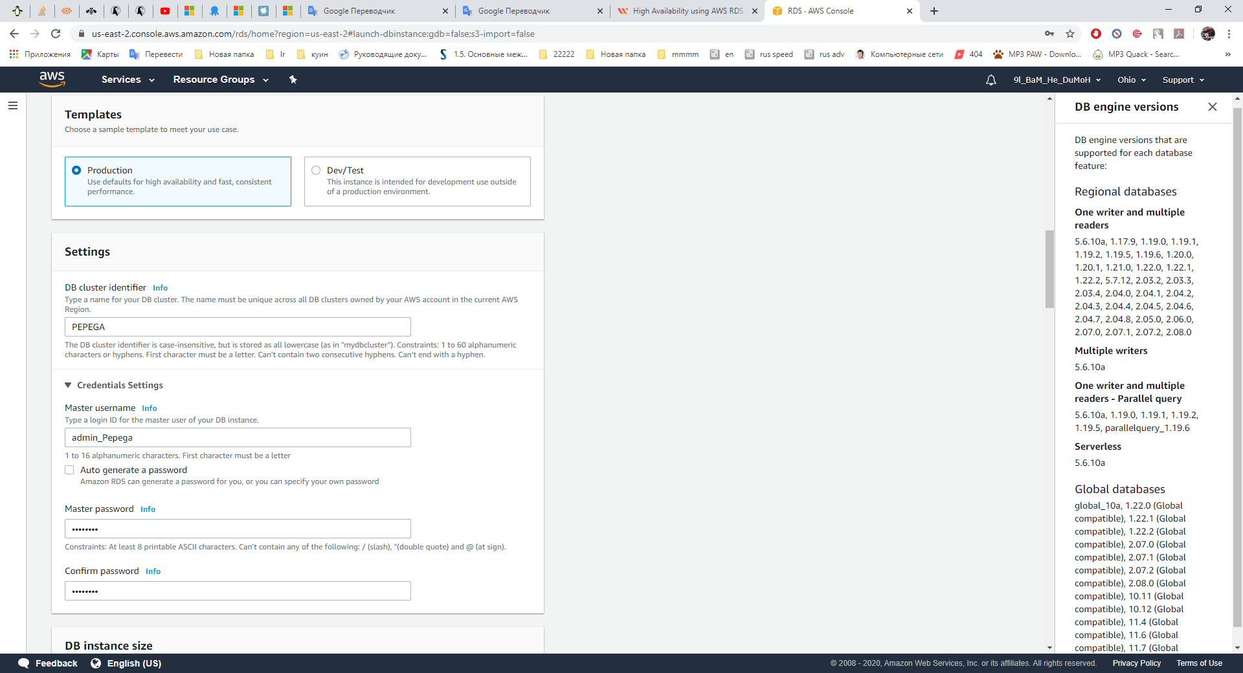

Configure instance size and durability

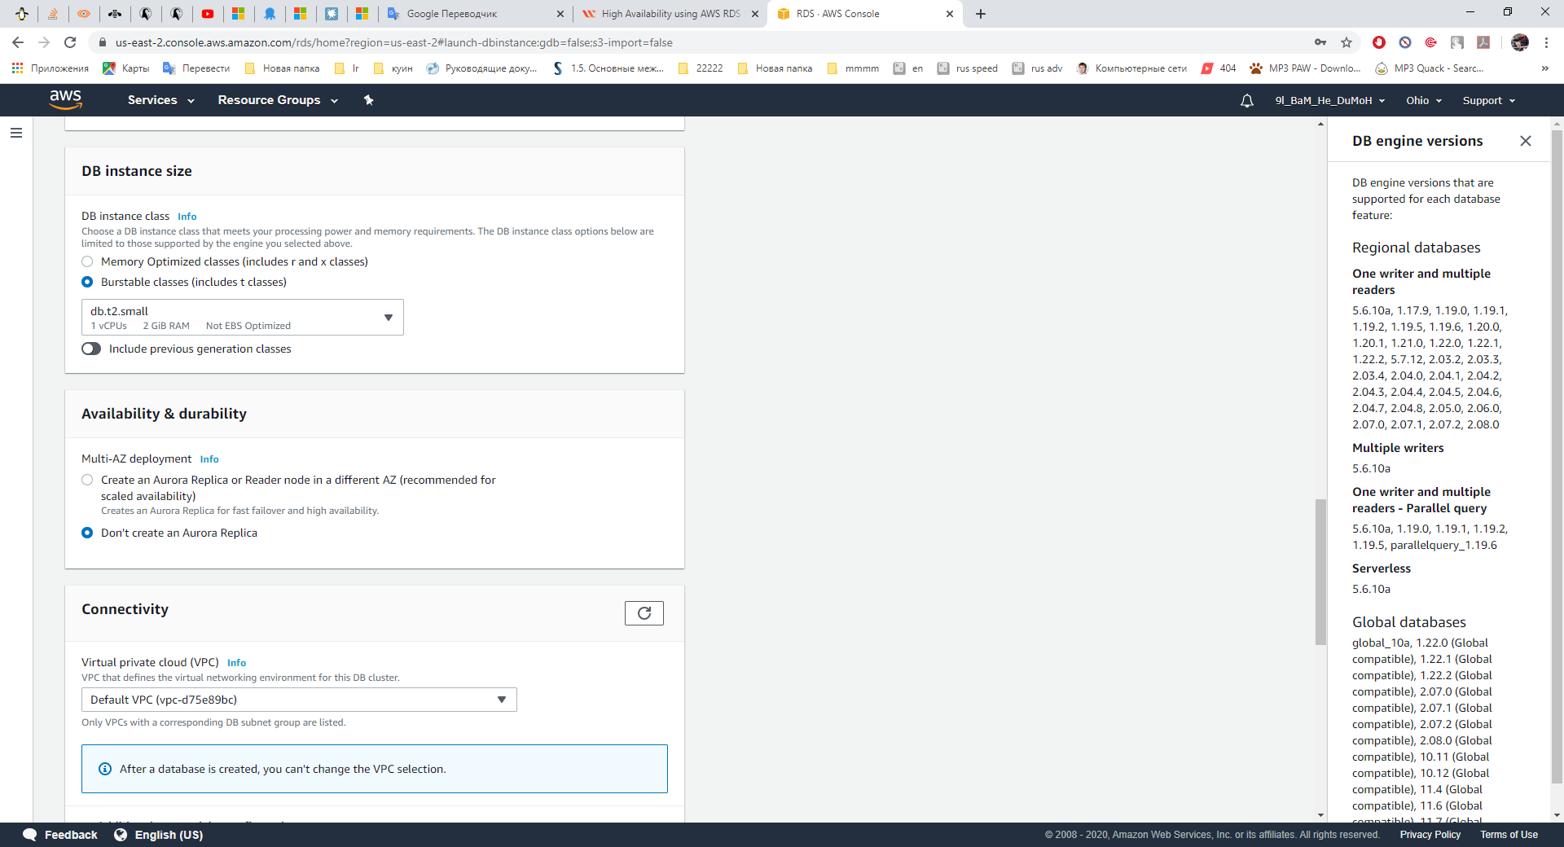

Set up avalibility

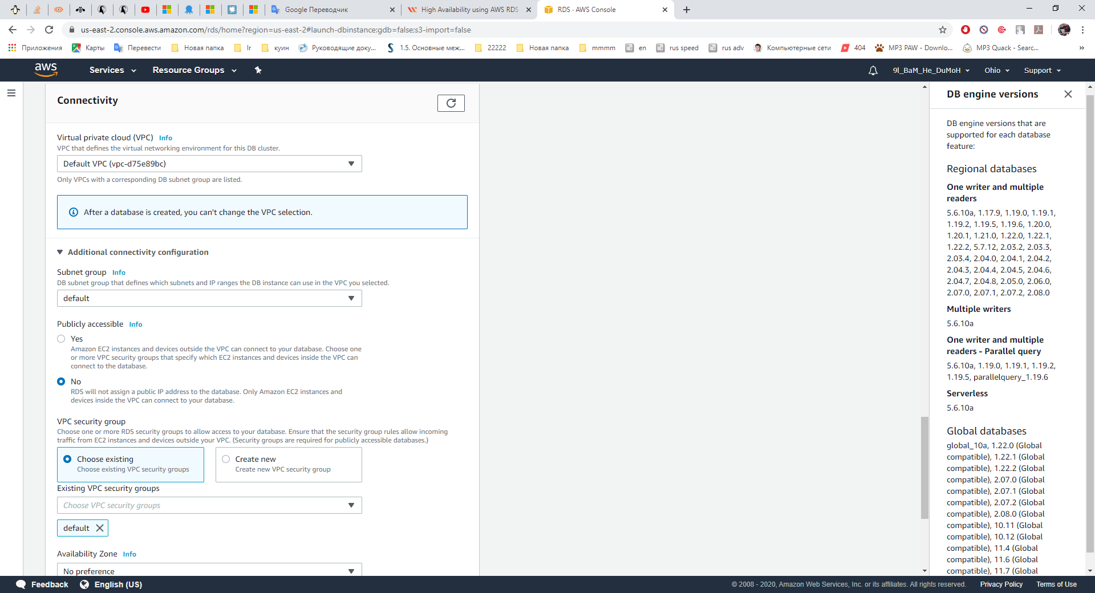

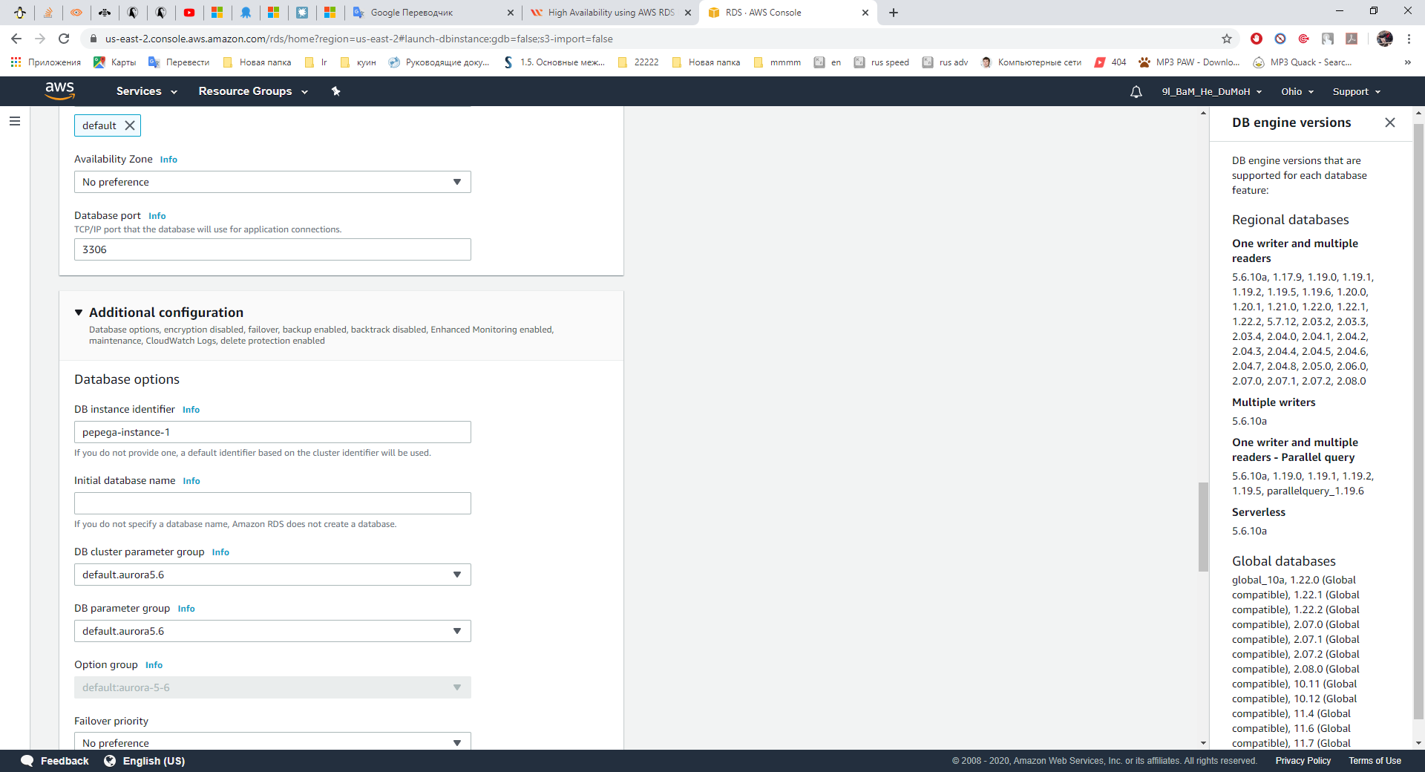

Additional configuration (allows you to create an additional name for database, configure parameter group, enable encryption, monitoring, rollback,etc.)



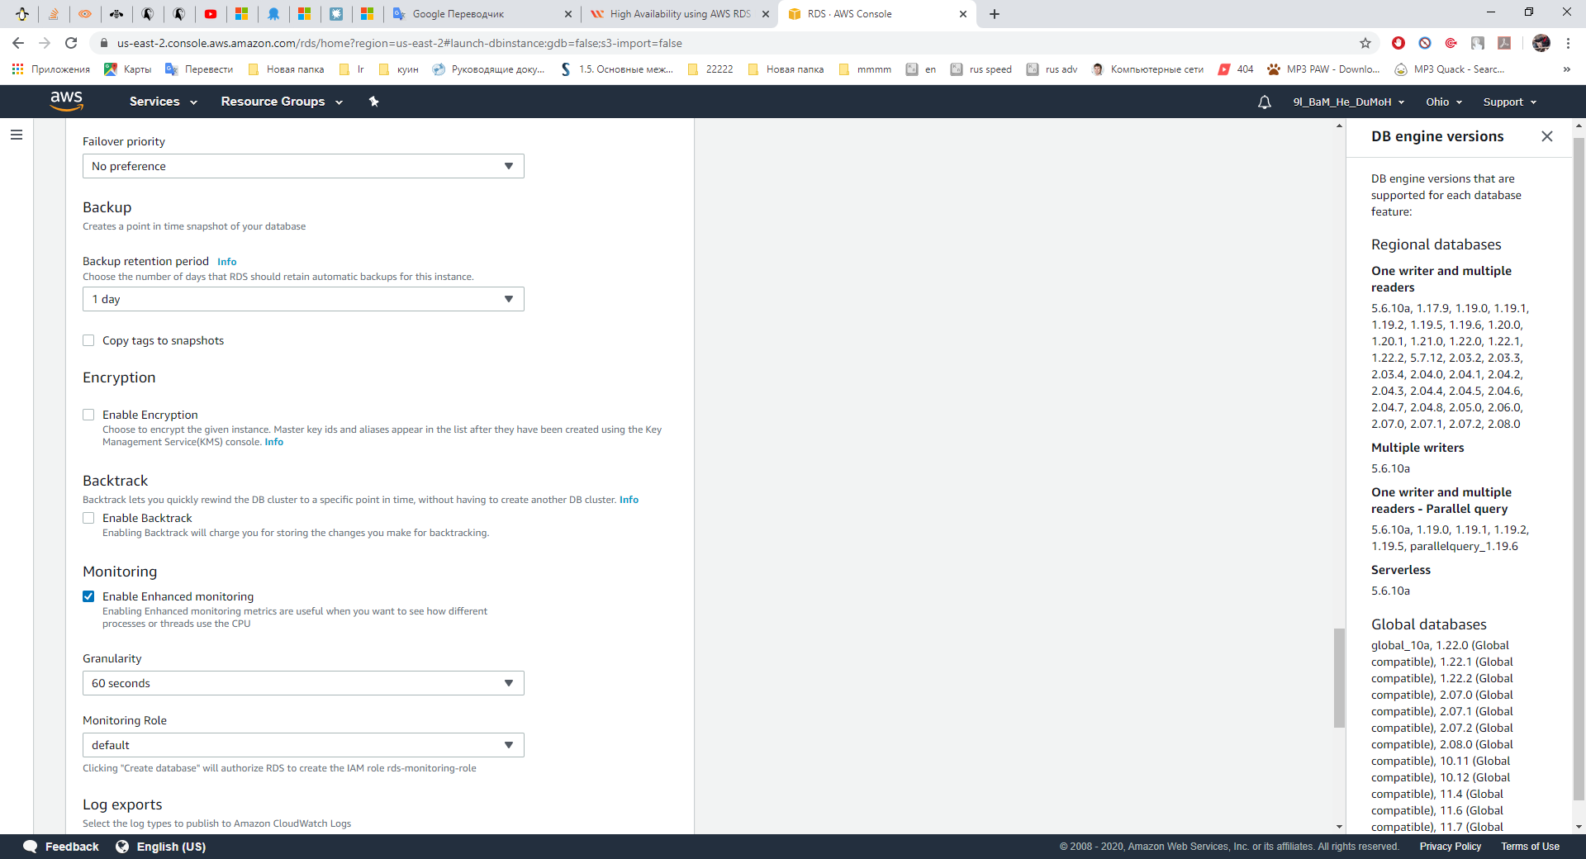

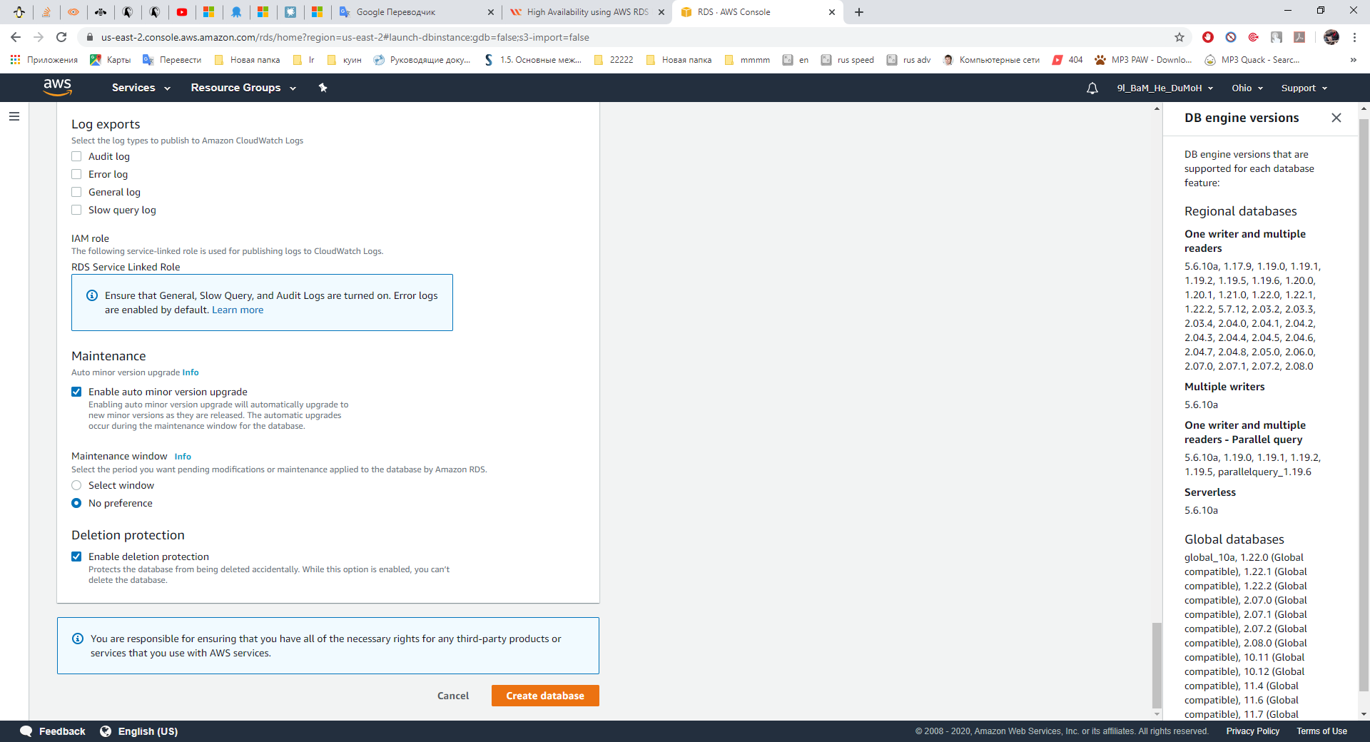

Database created

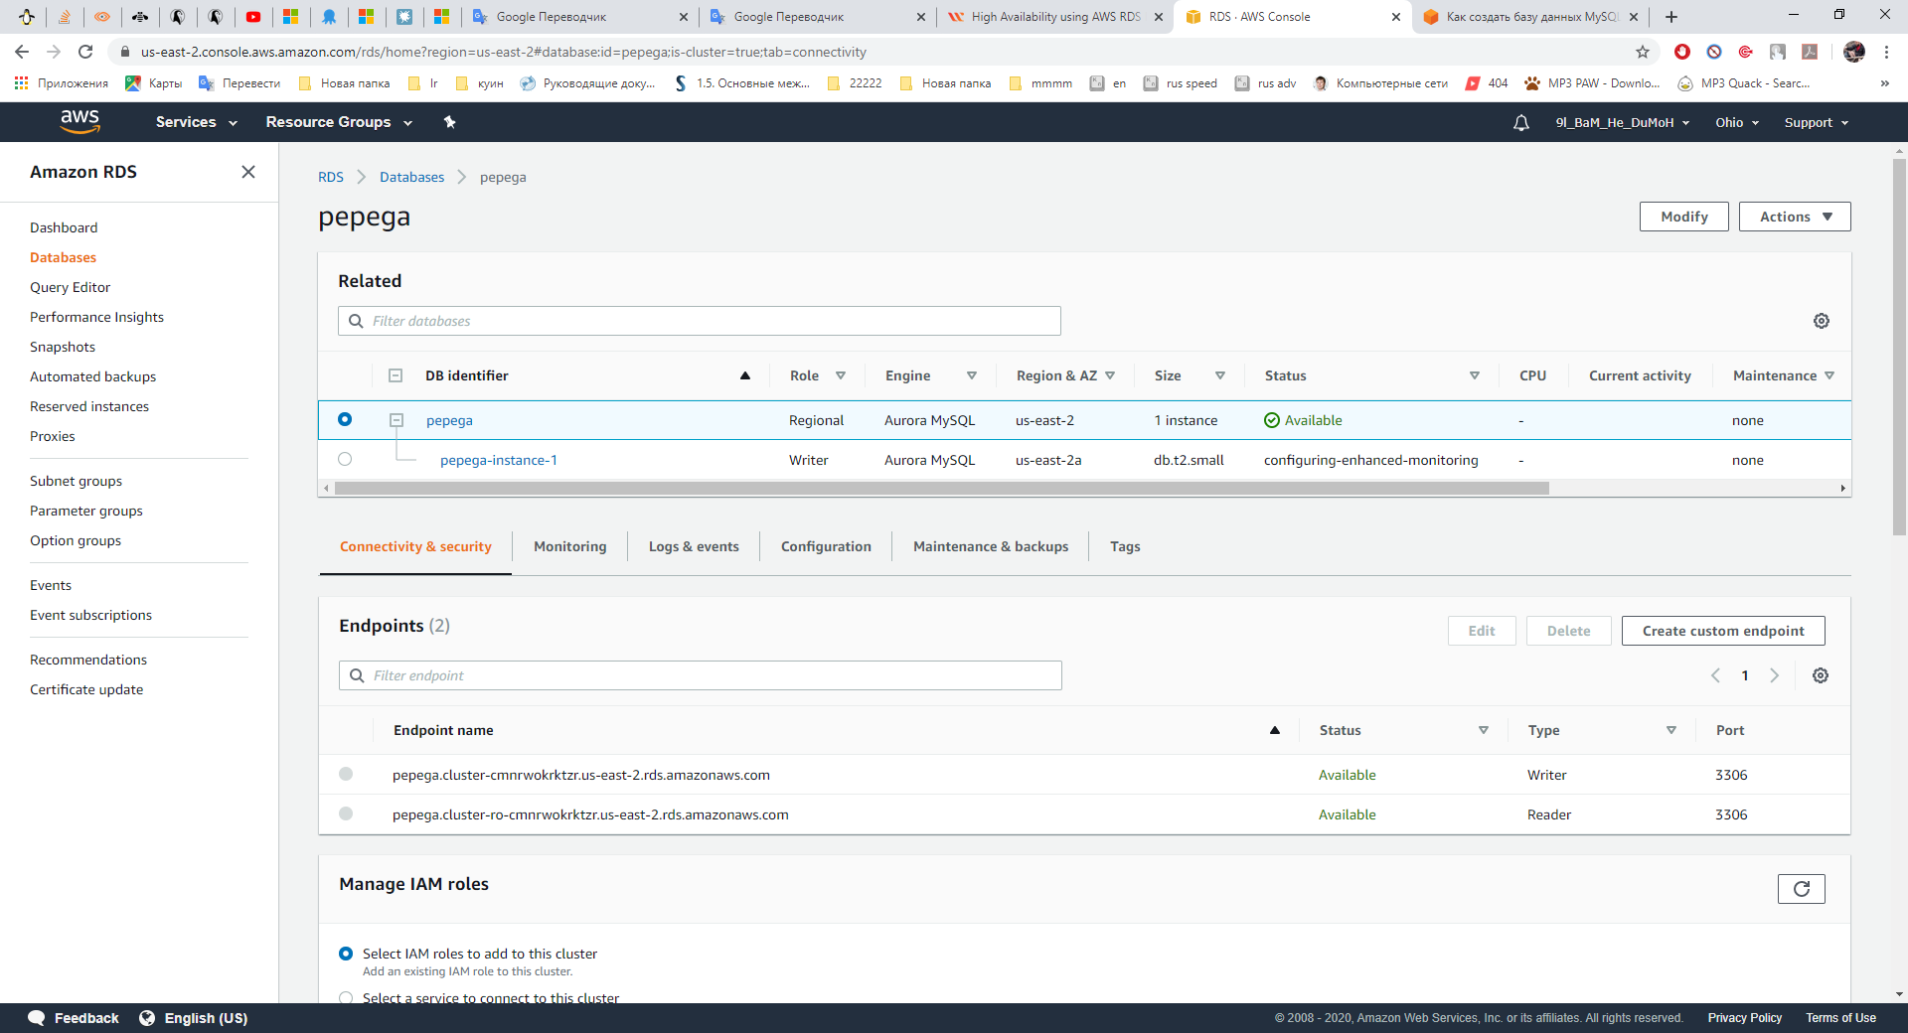

For deletion database choose Actions -> Delete



If you forgot uncheck “Enable deletion protection”, select Modify and uncheck

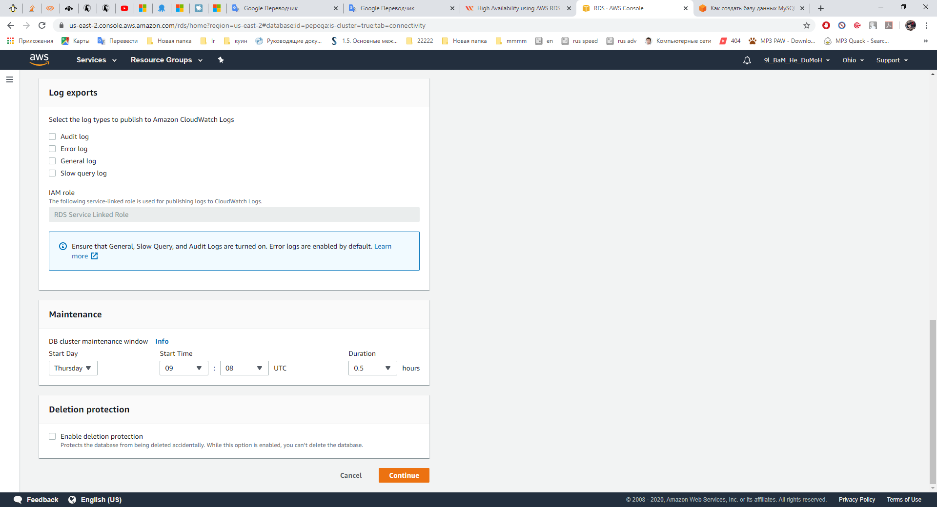

Then select Apply immediately -> Modify cluster

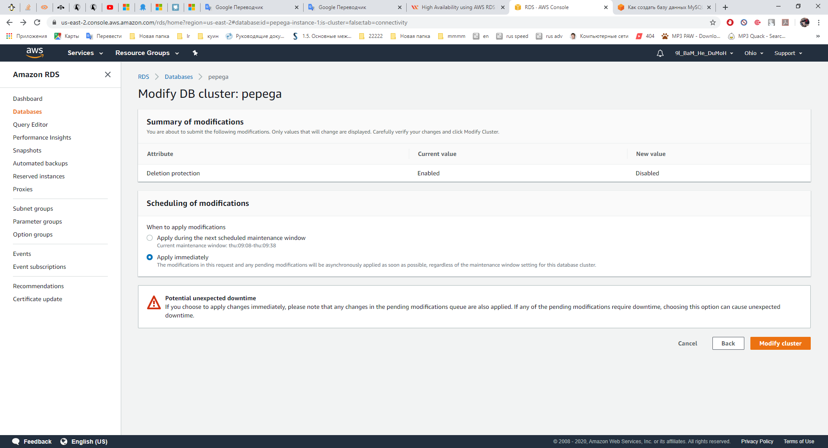

Confirm deletion

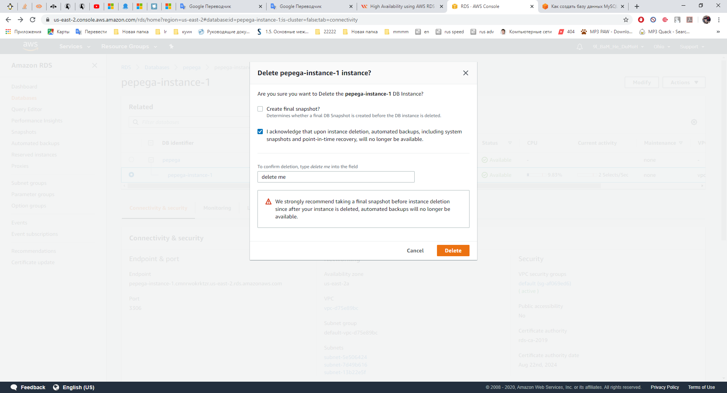

Check the results

Select Amazon Relational Database Service -> Databases

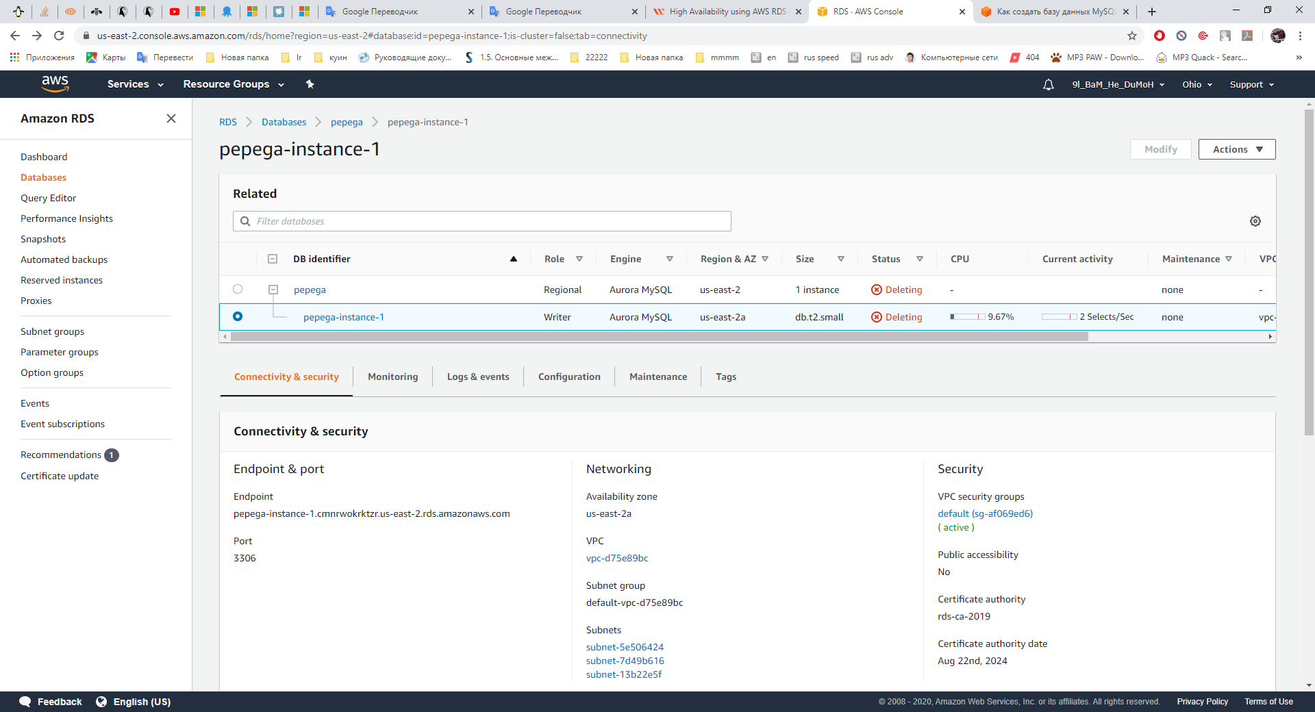

After a while

